**CONTENTS**

1. **INTRODUCTION** 
   1. Overview
   2. Purpose
2. **PROBLEM DEFINITION & DESIGN THINKING**
   1. Empathy Map
   2. Ideation & Brainstorming Map
3. **RESULT**
4. **ADVANTAGES & DISADVANTAGES**
5. **APPLICATIONS**
6. **CONCLUSION**
7. **FUTURE SCOPE**
8. **APPENDIX**
   1. Source Code

**INTRODUCTION**

Planning and tracking for your travels is an essential part of any trip. Whether you are planning a weekend getaway or a months-long adventure, being organized and keeping track of your itinerary can make your travels smoother and more enjoyable. By having a plan in place, you can maximize your time, avoid unnecessary stress, and ensure that you get to experience everything you want to during your trip.

* 1. **Overview:**
* Providing a personalized experience: Technology has made it easier than ever to plan and track your travel.
* Offering real-time updates: This apps can help you organize your itinerary, book transportation and accommodations, find local attractions and restaurants, and keep track of your expenses.
* Ensuring accuracy and reliability: From popular travel apps such as TripIt and Expedia, to niche apps like Couchsurfing and Lonely Planet.
* Enhancing engagement: In this guide, we will provide an overview of the top travel planning and tracking apps.
  1. **Purpose:**
* The purpose of travel planning and tracking apps is to make the process of planning and organizing a trip more efficient and convenient for travellers.
* These apps offer a range of features such as itinerary management, booking options, location information.
* By using travel apps, travellers can save time and avoid the hassle of keeping track of multiple bookings and reservations.

**PROBLEM DEFINITION & DESIGN THINKING**

**2.1 Empathy Map:**

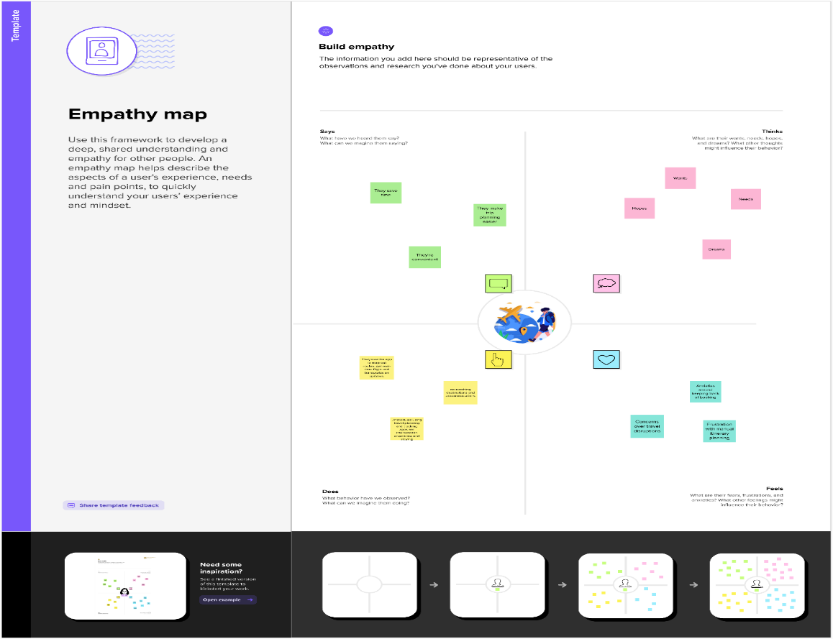

* 1. **Ideation & Brainstorming Map:**

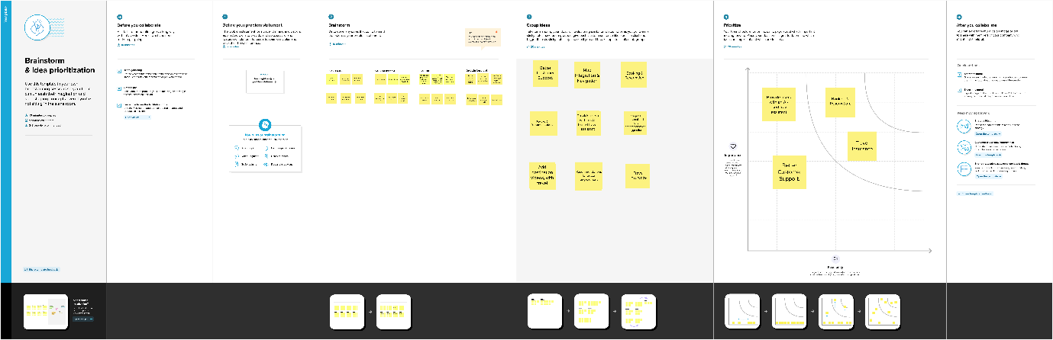

**Sign up page:**

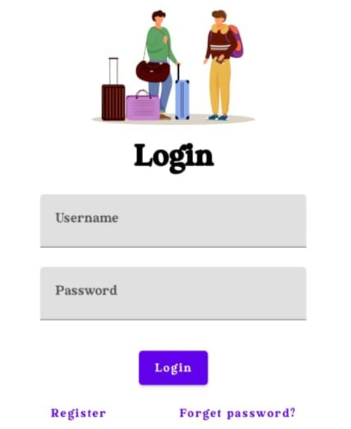

**Sign up page:**

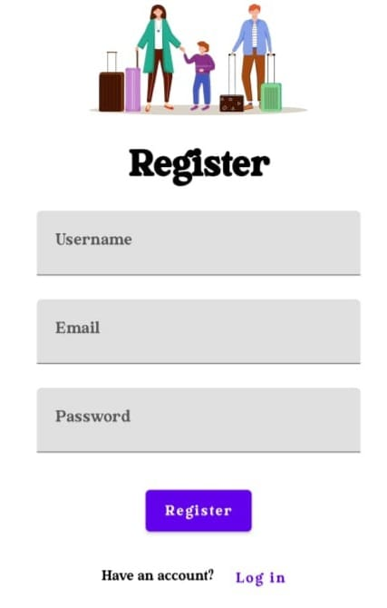

**Home Page:**

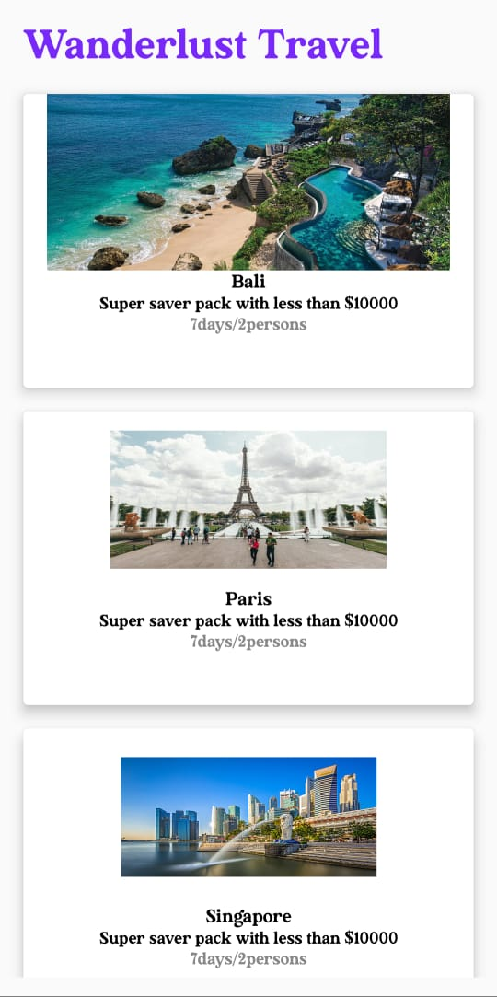

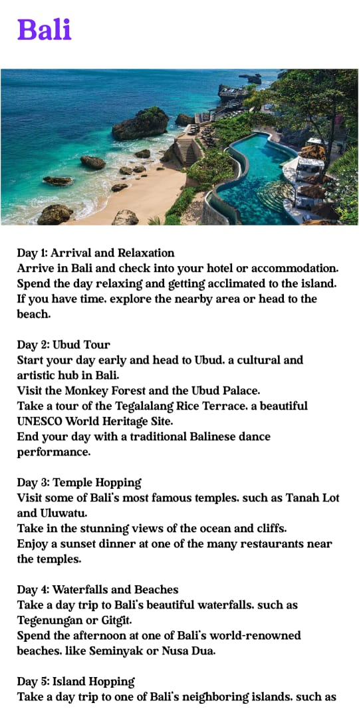

**Travel Page:**

**ADVANTAGES & DISADVANTAGES**

* 1. **Advantages:**
* Convenience: The travel apps allow users to compare and book flights, hotels, and activities all from one place, saving time and effort.
* Real-time updates: Many travel apps provide real-time updates on flight delays, gate changes, and weather alerts, keeping travellers informed of any changes that may affect their plans.
* Itinerary management: The travel apps allow users to create and manage their itinerary and organize their schedule, helping them stay on top of their plans and keep everything in one place.
  1. **Disadvantages:**
* Reliance on technology: The travel apps require an internet connection and rely heavily on technology, which can be a disadvantage if there is a poor connection or technical difficulties.
* Limited personalization: Some travel apps offer limited customization options, which may not suit the individual needs and preferences of all users.
* Information overload: With so much information available on travel apps, users may become overwhelmed and have difficulty narrowing down their options.
* Privacy concerns: Some travel apps require users to share personal information or location data, which may raise privacy concerns for some individuals.

**APPLICATIONS**

* Trip planning: The travel apps can help users plan their trip by searching for flights, hotels, car rentals, activities, and other travel arrangements in one convenient location.
* Itinerary management: Once travel arrangements are made, travel apps can help users create and manage their trip itinerary.
* Budget management: Some travel apps can help users set and manage their travel budget by tracking expenses and providing cost-saving tips.
* Navigation assistance: The travel apps with GPS functionality can help users navigate their destination, find nearby attractions, and get directions.
* Trip tracking: The travel apps can also be used to track flight and hotel reservations and receive real-time updates on any changes or delays.
* Business travel management: For business travellers, travel apps can be used to book and manage travel arrangements, track expenses, and submit expense reports.

**Conclusion**

We conclude that the travel planning and tracking app can be a valuable tool for travellers looking to streamline their itinerary, stay organized, and keep track of expenses. With features such as flight and hotel bookings, itinerary creation, expense tracking, weather updates, and more, these apps can make travel planning and execution easier and more efficient. The availability of such apps on multiple devices and platforms also allows for seamless integration and accessibility on the go. Overall, a travel planning and tracking app can help travellers make the most of their trips and experiences, providing a stress-free and enjoyable journey.

Future Scope

In future adding more sources to provide the travel planning and tracking app is designed to make it easier for users to plan and manage their trips. The app allows users to create and save travel itineraries, book accommodations and activities, and track their expenses. Users can also connect with other travellers and share their experiences and recommendations. The app provides helpful features such as weather updates, currency exchange rates, and local transportation options. Additionally, the app includes a tracking feature that allows users to monitor their travel progress and share it with friends and family. With the travel planning and tracking app, users can stay organized, save time, and make the most out of their trips.

**APPENDIX**

**Source code:**

**https://github.com/gokularun001/Travel-App**

**Code**

1. **BaliActivity.kt**

package com.example.travelapp

import android.os.Bundle

import androidx.activity.ComponentActivity

import androidx.activity.compose.setContent

import androidx.compose.foundation.Image

import androidx.compose.foundation.background

import androidx.compose.foundation.layout.*

import androidx.compose.foundation.rememberScrollState

import androidx.compose.foundation.verticalScroll

import androidx.compose.material.MaterialTheme

import androidx.compose.material.Surface

import androidx.compose.material.Text

import androidx.compose.runtime.Composable

import androidx.compose.ui.Modifier

import androidx.compose.ui.draw.scale

import androidx.compose.ui.graphics.Color

import androidx.compose.ui.res.painterResource

import androidx.compose.ui.res.stringResource

import androidx.compose.ui.text.font.FontFamily

import androidx.compose.ui.tooling.preview.Preview

import androidx.compose.ui.unit.dp

import androidx.compose.ui.unit.sp

import com.example.travelapp.ui.theme.TravelAppTheme

class BaliActivity : ComponentActivity() {

override fun onCreate(savedInstanceState: Bundle?) {

super.onCreate(savedInstanceState)

setContent {

TravelAppTheme {

// A surface container using the 'background' color from the theme

Surface(

modifier = Modifier.fillMaxSize(),

color = MaterialTheme.colors.background

) {

PlaceOne()

}

}

}

}

}

@Composable

fun PlaceOne() {

Column(modifier = Modifier.background(color = Color.White)

.padding(20.dp)

.verticalScroll(rememberScrollState())

) {

Text(

fontSize = 40.sp,

color = Color(android.graphics.Color.rgb(120, 40, 251)),

fontFamily = FontFamily.Cursive,

text = stringResource(id = R.string.place_1),

)

Image(

painterResource(id = R.drawable.bali), contentDescription = "",

modifier = Modifier

.padding(16.dp)

.fillMaxWidth()

.height(200.dp)

.scale(scaleX = 1.2F, scaleY = 1F)

)

Text(

color=Color.Black,

text = "Day 1: Arrival and Relaxation\n" +

"Arrive in Bali and check into your hotel or accommodation.\n" +

"Spend the day relaxing and getting acclimated to the island.\n" +

"If you have time, explore the nearby area or head to the beach.\n" +

"\n" +

"Day 2: Ubud Tour\n" +

"Start your day early and head to Ubud, a cultural and artistic hub in Bali.\n" +

"Visit the Monkey Forest and the Ubud Palace.\n" +

"Take a tour of the Tegalalang Rice Terrace, a beautiful UNESCO World Heritage Site.\n" +

"End your day with a traditional Balinese dance performance.\n" +

"\n" +

"Day 3: Temple Hopping\n" +

"Visit some of Bali's most famous temples, such as Tanah Lot and Uluwatu.\n" +

"Take in the stunning views of the ocean and cliffs.\n" +

"Enjoy a sunset dinner at one of the many restaurants near the temples.\n" +

"\n" +

"Day 4: Waterfalls and Beaches\n" +

"Take a day trip to Bali's beautiful waterfalls, such as Tegenungan or Gitgit.\n" +

"Spend the afternoon at one of Bali's world-renowned beaches, like Seminyak or Nusa Dua.\n" +

"\n" +

"Day 5: Island Hopping\n" +

"Take a day trip to one of Bali's neighboring islands, such as Nusa Lembongan or Gili Islands.\n" +

"Snorkel or scuba dive in the clear waters and relax on the beach.\n" +

"\n" +

"Day 6: Cultural Activities\n" +

"Visit a traditional Balinese village and learn about the island.\n" +

"\n" +

"Day 7: Departure\n" +

"Explore the surrounding area and take in the stunning sunset views.\n" +

"Have dinner at a local restaurant before returning to your accommodation."

)

}

}

1. **LoginActivity.kt**

package com.example.travelapp

import android.content.Context

import android.content.Intent

import android.os.Bundle

import androidx.activity.ComponentActivity

import androidx.activity.compose.setContent

import androidx.compose.foundation.Image

import androidx.compose.foundation.background

import androidx.compose.foundation.layout.*

import androidx.compose.material.*

import androidx.compose.runtime.*

import androidx.compose.ui.Alignment

import androidx.compose.ui.Modifier

import androidx.compose.ui.graphics.Color

import androidx.compose.ui.layout.ContentScale

import androidx.compose.ui.res.painterResource

import androidx.compose.ui.text.font.FontFamily

import androidx.compose.ui.text.font.FontWeight

import androidx.compose.ui.text.input.PasswordVisualTransformation

import androidx.compose.ui.tooling.preview.Preview

import androidx.compose.ui.unit.dp

import androidx.compose.ui.unit.sp

import androidx.core.content.ContextCompat

class LoginActivity : ComponentActivity() {

private lateinit var databaseHelper: UserDatabaseHelper

override fun onCreate(savedInstanceState: Bundle?) {

super.onCreate(savedInstanceState)

databaseHelper = UserDatabaseHelper(this)

setContent {

LoginScreen(this, databaseHelper)

}

}

}

@Composable

fun LoginScreen(context: Context, databaseHelper: UserDatabaseHelper) {

var username by remember { mutableStateOf("") }

var password by remember { mutableStateOf("") }

var error by remember { mutableStateOf("") }

Column(

modifier = Modifier.fillMaxSize().background(Color.White),

horizontalAlignment = Alignment.CenterHorizontally,

verticalArrangement = Arrangement.Center

) {

Image(painterResource(id = R.drawable.trav), contentDescription = "")

Text(

fontSize = 36.sp,

fontWeight = FontWeight.ExtraBold,

fontFamily = FontFamily.Cursive,

text = "Login"

)

Spacer(modifier = Modifier.height(10.dp))

TextField(

value = username,

onValueChange = { username = it },

label = { Text("Username") },

modifier = Modifier.padding(10.dp)

.width(280.dp)

)

TextField(

value = password,

onValueChange = { password = it },

label = { Text("Password") },

visualTransformation = PasswordVisualTransformation(),

modifier = Modifier.padding(10.dp)

.width(280.dp)

)

if (error.isNotEmpty()) {

Text(

text = error,

color = MaterialTheme.colors.error,

modifier = Modifier.padding(vertical = 16.dp)

)

}

Button(

onClick = {

if (username.isNotEmpty() && password.isNotEmpty()) {

val user = databaseHelper.getUserByUsername(username)

if (user != null && user.password == password) {

error = "Successfully log in"

context.startActivity(

Intent(

context,

MainActivity::class.java

)

)

//onLoginSuccess()

}

else {

error = "Invalid username or password"

}

} else {

error = "Please fill all fields"

}

},

modifier = Modifier.padding(top = 16.dp)

) {

Text(text = "Login")

}

Row {

TextButton(onClick = {context.startActivity(

Intent(

context,

RegisterActivity::class.java

)

)}

)

{ Text(text = "Register") }

TextButton(onClick = {

})

{

Spacer(modifier = Modifier.width(60.dp))

Text(text = "Forget password?")

}

}

}

}

private fun startMainPage(context: Context) {

val intent = Intent(context, MainActivity::class.java)

ContextCompat.startActivity(context, intent, null)

}

1. **MainActivity.kt**

package com.example.travelapp

import android.content.Context

import android.content.Intent

import android.os.Bundle

import androidx.activity.ComponentActivity

import androidx.activity.compose.setContent

import androidx.compose.foundation.Image

import androidx.compose.foundation.clickable

import androidx.compose.foundation.layout.*

import androidx.compose.foundation.rememberScrollState

import androidx.compose.foundation.verticalScroll

import androidx.compose.material.Card

import androidx.compose.material.Text

import androidx.compose.runtime.Composable

import androidx.compose.ui.Alignment

import androidx.compose.ui.Modifier

import androidx.compose.ui.draw.scale

import androidx.compose.ui.graphics.Color

import androidx.compose.ui.res.painterResource

import androidx.compose.ui.res.stringResource

import androidx.compose.ui.text.font.FontFamily

import androidx.compose.ui.text.font.FontWeight

import androidx.compose.ui.text.style.TextAlign

import androidx.compose.ui.unit.dp

import androidx.compose.ui.unit.sp

class MainActivity : ComponentActivity() {

override fun onCreate(savedInstanceState: Bundle?) {

super.onCreate(savedInstanceState)

setContent {

TravelApp(this)

}

}

@Composable

fun TravelApp(context: Context) {

Column(

modifier = Modifier

.padding(20.dp)

.verticalScroll(rememberScrollState())

) {

Text(

fontSize = 40.sp,

color = Color(android.graphics.Color.rgb(120, 40, 251)),

fontFamily = FontFamily.Cursive,

text = "Wanderlust Travel"

)

Spacer(modifier = Modifier.height(20.dp))

// 01

Card(

modifier = Modifier

.fillMaxWidth()

.height(250.dp)

.clickable {

context.startActivity(

Intent(context, BaliActivity::class.java)

)

},

elevation = 8.dp

)

{

Column(

horizontalAlignment = Alignment.CenterHorizontally

) {

Image(

painterResource(id = R.drawable.bali), contentDescription = "",

modifier = Modifier

.height(150.dp)

.scale(scaleX = 1.2F, scaleY = 1F)

)

Text(

text = stringResource(id = R.string.place_1),

fontSize = 18.sp

)

Text(

text = stringResource(id = R.string.description),

fontWeight = FontWeight.Light,

fontSize = 16.sp,

textAlign = TextAlign.Center,

)

Text(

text = stringResource(id = R.string.plan), color = Color.Gray,

fontSize = 16.sp

)

}

}

Spacer(modifier = Modifier.height(20.dp))

//02

Card(

modifier = Modifier

.fillMaxWidth()

.height(250.dp)

.clickable {

context.startActivity(

Intent(context, ParisActivity::class.java)

)

},

elevation = 8.dp

)

{

Column(

horizontalAlignment = Alignment.CenterHorizontally

) {

Image(

painterResource(id = R.drawable.paris), contentDescription = "",

modifier = Modifier

.height(150.dp)

.scale(scaleX = 1.2F, scaleY = 1F)

)

Text(

text = stringResource(id = R.string.place_2),

fontSize = 18.sp

)

Text(

text = stringResource(id = R.string.description),

fontWeight = FontWeight.Light,

fontSize = 16.sp,

textAlign = TextAlign.Center,

)

Text(

text = stringResource(id = R.string.plan), color = Color.Gray,

fontSize = 16.sp

)

}

}

Spacer(modifier = Modifier.height(20.dp))

//03

Card(

modifier = Modifier

.fillMaxWidth()

.height(250.dp)

.clickable {

context.startActivity(

Intent(context, SingaporeActivity::class.java)

)

},

elevation = 8.dp

)

{

Column(

horizontalAlignment = Alignment.CenterHorizontally

) {

Image(

painterResource(id = R.drawable.singapore), contentDescription = "",

modifier = Modifier

.height(150.dp)

.scale(scaleX = 1.2F, scaleY = 1F)

)

Text(

text = stringResource(id = R.string.place_3),

fontSize = 18.sp

)

Text(

text = stringResource(id = R.string.description),

fontWeight = FontWeight.Light,

fontSize = 16.sp,

textAlign = TextAlign.Center,

)

Text(

text = stringResource(id = R.string.plan), color = Color.Gray,

fontSize = 16.sp

)

}

}

Spacer(modifier = Modifier.height(20.dp))

}

}

}

1. **ParisActivity.kt**

import android.os.Bundle

import androidx.activity.ComponentActivity

import androidx.activity.compose.setContent

import androidx.compose.foundation.Image

import androidx.compose.foundation.background

import androidx.compose.foundation.layout.*

import androidx.compose.foundation.rememberScrollState

import androidx.compose.foundation.verticalScroll

import androidx.compose.material.MaterialTheme

import androidx.compose.material.Surface

import androidx.compose.material.Text

import androidx.compose.runtime.Composable

import androidx.compose.ui.Modifier

import androidx.compose.ui.draw.scale

import androidx.compose.ui.graphics.Color

import androidx.compose.ui.res.painterResource

import androidx.compose.ui.res.stringResource

import androidx.compose.ui.text.font.FontFamily

import androidx.compose.ui.tooling.preview.Preview

import androidx.compose.ui.unit.dp

import androidx.compose.ui.unit.sp

import com.example.travelapp.ui.theme.TravelAppTheme

class ParisActivity : ComponentActivity() {

override fun onCreate(savedInstanceState: Bundle?) {

super.onCreate(savedInstanceState)

setContent {

TravelAppTheme {

// A surface container using the 'background' color from the theme

Surface(

modifier = Modifier.fillMaxSize(),

color = MaterialTheme.colors.background

) {

Greeting()

}

}

}

}

}

@Composable

fun Greeting() {

Column(

modifier = Modifier.background(color = Color.White)

.padding(20.dp)

.verticalScroll(rememberScrollState())

) {

Text(

fontSize = 40.sp,

color = Color(android.graphics.Color.rgb(120, 40, 251)),

fontFamily = FontFamily.Cursive,

text = stringResource(id = R.string.place_2),

)

Image(

painterResource(id = R.drawable.paris), contentDescription = "",

modifier = Modifier

.padding(16.dp)

.fillMaxWidth()

.height(200.dp)

.scale(scaleX = 1.2F, scaleY = 1F)

)

Text(

color=Color.Black,

text = "Day 1: Arrival and Introduction\n" +

"Check into your accommodation and freshen up\n" +

"Take a stroll around the neighborhood to get acquainted\n" +

"Visit the Eiffel Tower, preferably in the evening when it is lit up\n" +

"Have a relaxing dinner at a nearby restaurant\n" +

"\n" +

"Day 2: Art and History\n" +

"Visit the Louvre Museum to see some of the world's most famous art pieces\n" +

"Stroll through the Tuileries Garden and the Place de la Concorde\n" +

"Visit the Orsay Museum, which houses a large collection of impressionist art\n" +

"Have dinner at a local French restaurant\n" +

"\n" +

"Day 3: French Culture and Food\n" +

"Visit the Montmartre neighborhood to see the famous Basilique du Sacré-Cœur and Place du Tertre\n" +

"Explore the historic neighborhood of Le Marais\n" +

"Try some delicious French pastries at a local bakery\n" +

"Have dinner at a brasserie to taste some classic French cuisine\n" +

"\n" +

"Day 4: Architecture and Gardens\n" +

"Visit the Palace of Versailles, a UNESCO World Heritage site, and explore its beautiful gardens\n" +

"Walk along the Champs-Elysées and stop at the Arc de Triomphe\n" +

"Visit the Sainte-Chapelle, a beautiful Gothic chapel with stunning stained-glass windows\n" +

"Have dinner at a local restaurant in the 7th arrondissement\n" +

"\n" +

"Day 5: Shopping and Sightseeing\n" +

"Visit the Notre-Dame Cathedral and climb up to the top for a stunning view of the city\n" +

"Explore the Latin Quarter and visit the Panthéon\n" +

"Go shopping at the famous Galeries Lafayette or Printemps department stores\n" +

"Have dinner at a local bistro\n" +

"\n" +

"Day 6: Parisian Parks and Museums\n" +

"Visit the Musée Rodin and explore its beautiful gardens\n" +

"Stroll through the Luxembourg Gardens and visit the Luxembourg Palace\n" +

"Visit the Centre Pompidou, a modern art museum in the Marais neighborhood\n" +

"Have dinner at a local restaurant in the Latin Quarter\n" +

"\n" +

"Day 7: River Cruise and Farewell\n" +

"Take a boat cruise along the Seine River to see the city from a different perspective\n" +

"Visit the Musée de l'Orangerie, which houses Monet's famous water lilies paintings\n" +

"Have a farewell dinner at a Michelin-starred restaurant"

)

}

}

1. **RegisterActivity.kt**

package com.example.travelapp

import android.content.Context

import android.content.Intent

import android.os.Bundle

import androidx.activity.ComponentActivity

import androidx.activity.compose.setContent

import androidx.compose.foundation.Image

import androidx.compose.foundation.background

import androidx.compose.foundation.layout.*

import androidx.compose.material.*

import androidx.compose.runtime.*

import androidx.compose.ui.Alignment

import androidx.compose.ui.Modifier

import androidx.compose.ui.graphics.Color

import androidx.compose.ui.layout.ContentScale

import androidx.compose.ui.res.painterResource

import androidx.compose.ui.text.font.FontFamily

import androidx.compose.ui.text.font.FontWeight

import androidx.compose.ui.text.input.PasswordVisualTransformation

import androidx.compose.ui.tooling.preview.Preview

import androidx.compose.ui.unit.dp

import androidx.compose.ui.unit.sp

import androidx.core.content.ContextCompat

class RegisterActivity : ComponentActivity() {

private lateinit var databaseHelper: UserDatabaseHelper

override fun onCreate(savedInstanceState: Bundle?) {

super.onCreate(savedInstanceState)

databaseHelper = UserDatabaseHelper(this)

setContent {

RegistrationScreen(this, databaseHelper)

}

}

}

@Composable

fun RegistrationScreen(context: Context, databaseHelper: UserDatabaseHelper) {

var username by remember { mutableStateOf("") }

var password by remember { mutableStateOf("") }

var email by remember { mutableStateOf("") }

var error by remember { mutableStateOf("") }

Column(

modifier = Modifier.fillMaxSize().background(Color.White),

horizontalAlignment = Alignment.CenterHorizontally,

verticalArrangement = Arrangement.Center

) {

Image(painterResource(id = R.drawable.tra), contentDescription = "")

Text(

fontSize = 36.sp,

fontWeight = FontWeight.ExtraBold,

fontFamily = FontFamily.Cursive,

text = "Register"

)

Spacer(modifier = Modifier.height(10.dp))

TextField(

value = username,

onValueChange = { username = it },

label = { Text("Username") },

modifier = Modifier

.padding(10.dp)

.width(280.dp)

)

TextField(

value = email,

onValueChange = { email = it },

label = { Text("Email") },

modifier = Modifier

.padding(10.dp)

.width(280.dp)

)

TextField(

value = password,

onValueChange = { password = it },

label = { Text("Password") },

visualTransformation = PasswordVisualTransformation(),

modifier = Modifier

.padding(10.dp)

.width(280.dp)

)

if (error.isNotEmpty()) {

Text(

text = error,

color = MaterialTheme.colors.error,

modifier = Modifier.padding(vertical = 16.dp)

)

}

Button(

onClick = {

if (username.isNotEmpty() && password.isNotEmpty() && email.isNotEmpty()) {

val user = User(

id = null,

firstName = username,

lastName = null,

email = email,

password = password

)

databaseHelper.insertUser(user)

error = "User registered successfully"

// Start LoginActivity using the current context

context.startActivity(

Intent(

context,

LoginActivity::class.java

)

)

} else {

error = "Please fill all fields"

}

},

modifier = Modifier.padding(top = 16.dp)

) {

Text(text = "Register")

}

Spacer(modifier = Modifier.width(10.dp))

Spacer(modifier = Modifier.height(10.dp))

Row() {

Text(

modifier = Modifier.padding(top = 14.dp), text = "Have an account?"

)

TextButton(onClick = {

context.startActivity(

Intent(

context,

LoginActivity::class.java

)

)

})

{

Spacer(modifier = Modifier.width(10.dp))

Text(text = "Log in")

}

}

}

}

private fun startLoginActivity(context: Context) {

val intent = Intent(context, LoginActivity::class.java)

ContextCompat.startActivity(context, intent, null)

}

1. **SinaporeActivity.kt**

package com.example.travelapp

import android.os.Bundle

import androidx.activity.ComponentActivity

import androidx.activity.compose.setContent

import androidx.compose.foundation.Image

import androidx.compose.foundation.background

import androidx.compose.foundation.layout.*

import androidx.compose.foundation.rememberScrollState

import androidx.compose.foundation.verticalScroll

import androidx.compose.material.MaterialTheme

import androidx.compose.material.Surface

import androidx.compose.material.Text

import androidx.compose.runtime.Composable

import androidx.compose.ui.Modifier

import androidx.compose.ui.draw.scale

import androidx.compose.ui.graphics.Color

import androidx.compose.ui.res.painterResource

import androidx.compose.ui.res.stringResource

import androidx.compose.ui.text.font.FontFamily

import androidx.compose.ui.tooling.preview.Preview

import androidx.compose.ui.unit.dp

import androidx.compose.ui.unit.sp

import com.example.travelapp.ui.theme.TravelAppTheme

class SingaporeActivity : ComponentActivity() {

override fun onCreate(savedInstanceState: Bundle?) {

super.onCreate(savedInstanceState)

setContent {

TravelAppTheme {

// A surface container using the 'background' color from the theme

Surface(

modifier = Modifier.fillMaxSize(),

color = MaterialTheme.colors.background

) {

Greeting2()

}

}

}

}

}

@Composable

fun Greeting2() {

Column(

modifier = Modifier.background(color = Color.White)

.padding(20.dp)

.verticalScroll(rememberScrollState())

) {

Text(

fontSize = 40.sp,

color = Color(android.graphics.Color.rgb(120, 40, 251)),

fontFamily = FontFamily.Cursive,

text = stringResource(id = R.string.place_3),

)

Image(

painterResource(id = R.drawable.singapore), contentDescription = "",

modifier = Modifier

.padding(16.dp)

.fillMaxWidth()

.height(200.dp)

.scale(scaleX = 1.2F, scaleY = 1F)

)

Text(

color = Color.Black,

text = "Day 1:\n" +

"Morning: Visit Gardens by the Bay and marvel at the Supertree Grove and the Flower Dome and Cloud Forest conservatories.\n" +

"Afternoon: Explore the Marina Bay Sands complex, which includes a casino, luxury shopping mall, and observation deck with a stunning view of the city.\n" +

"\n" +

"Day 2:\n" +

"Morning: Explore the historic district of Chinatown, including the Buddha Tooth Relic Temple and Museum and the Sri Mariamman Temple.\n" +

"Afternoon: Visit the nearby Clarke Quay for lunch and to explore its waterfront restaurants, bars, and shops.\n" +

"\n" +

"Day 3:\n" +

"Morning: Take a tour of the UNESCO-listed Botanic Gardens, one of the world's most famous and significant tropical gardens.\n" +

"Afternoon: Head over to the National Museum of Singapore, which houses a vast collection of historical and cultural artifacts.\n" +

"\n" +

"Day 4:\n" +

"Morning: Visit the Singapore Zoo and admire the wildlife, including orangutans, tigers, and elephants.\n" +

"Afternoon: Head over to Sentosa Island and relax at one of its many beaches or try some of the many attractions such as Universal Studios Singapore or Adventure Cove Waterpark.\n" +

"\n" +

"Day 5:\n" +

"Morning: Go on a nature walk at MacRitchie Reservoir, which offers hiking trails and stunning views of the city skyline.\n" +

"Afternoon: Visit Little India, a vibrant and colorful neighborhood, and explore the shops, temples, and food stalls.\n" +

"\n" +

"Day 6:\n" +

"Morning: Explore the trendy neighborhood of Tiong Bahru, known for its hip cafes and boutiques, as well as its Art Deco architecture.\n" +

"Afternoon: Visit the National Gallery Singapore, which houses the largest public collection of modern art in Singapore and Southeast Asia.\n" +

"\n" +

"Day 7:\n" +

"Morning: Take a day trip to the nearby island of Pulau Ubin, where you can rent a "

)

}

}